1.Data Cleaning & Modeling:
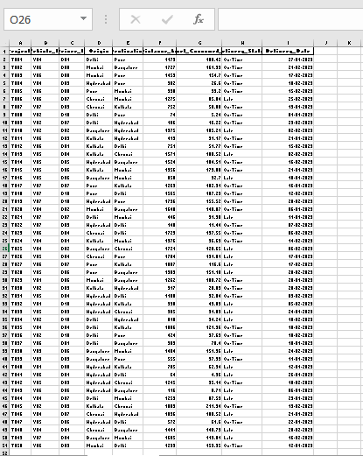
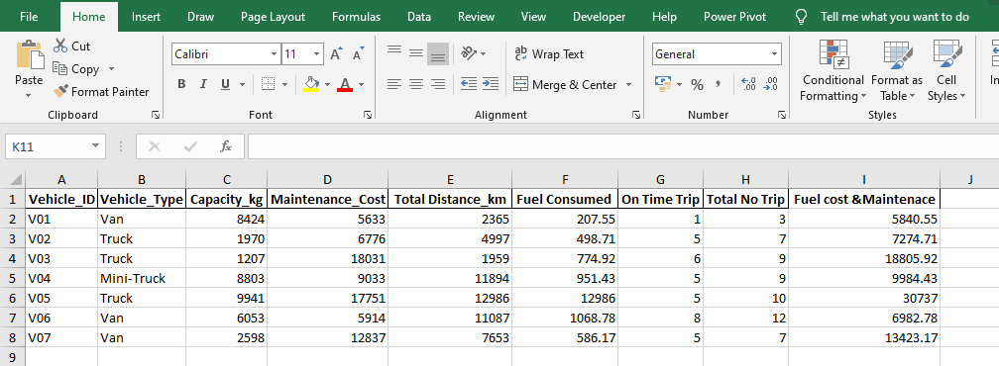

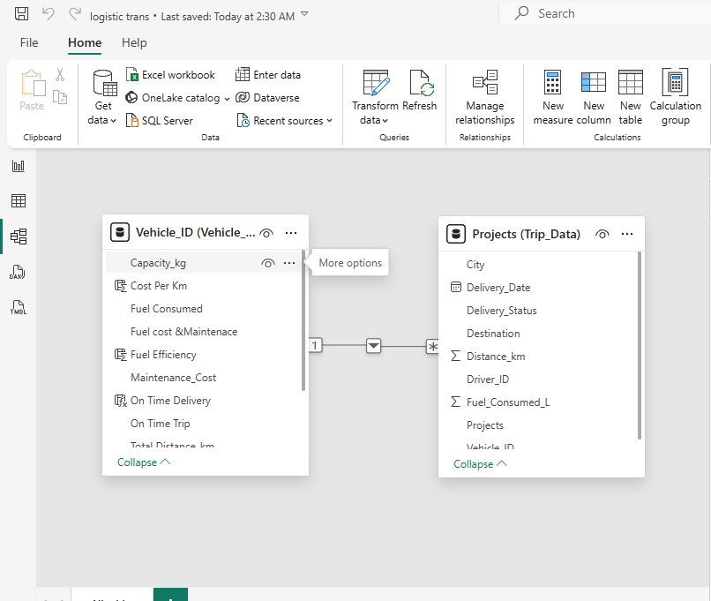
2. DAX Measures:
2.1 Fuel Efficiency:
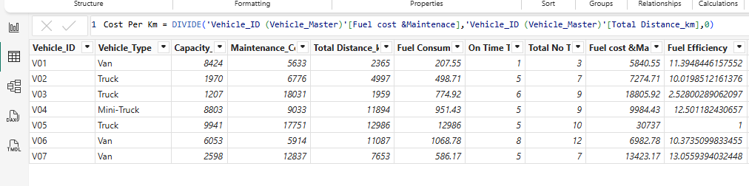
2.2 On Time Delivery % :
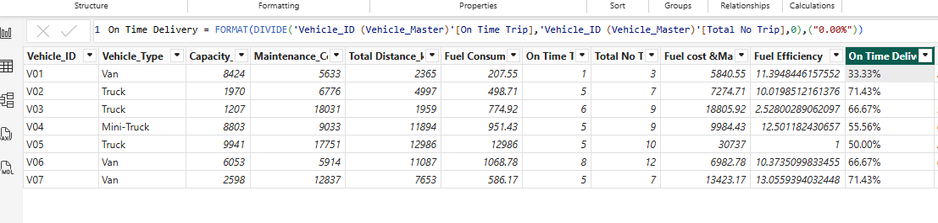
2.3 Cost Per KM :
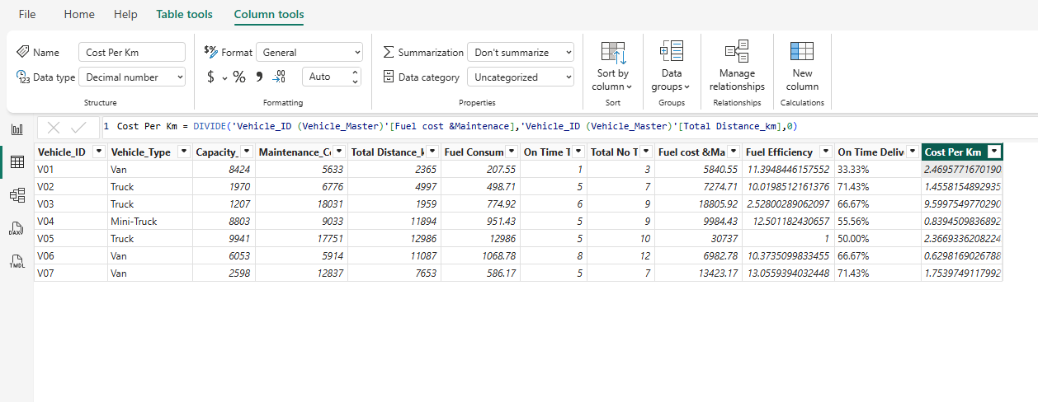
3. Visualization:
3.1 Bar Chart:
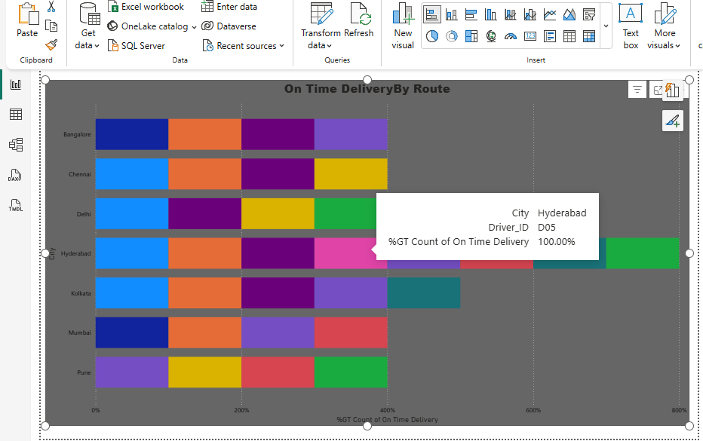

3.2 Line Chart:
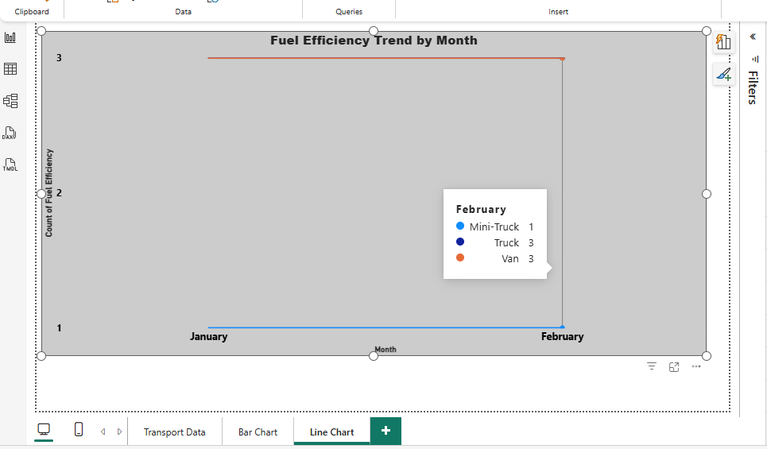
3.3 KPI Cards:
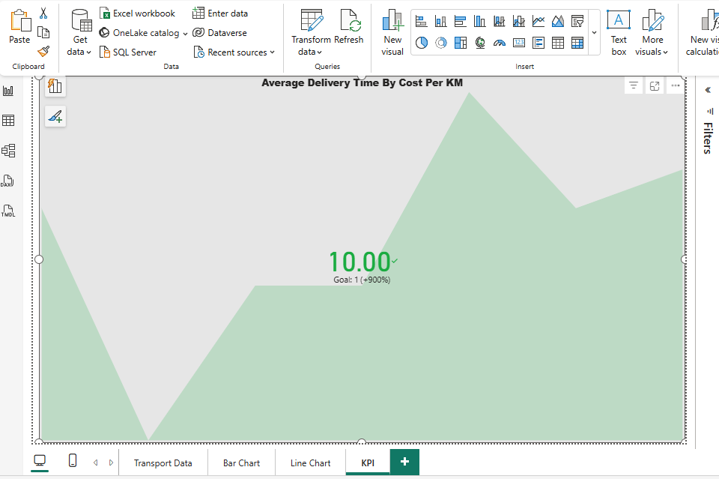

3.4 Map Visual:
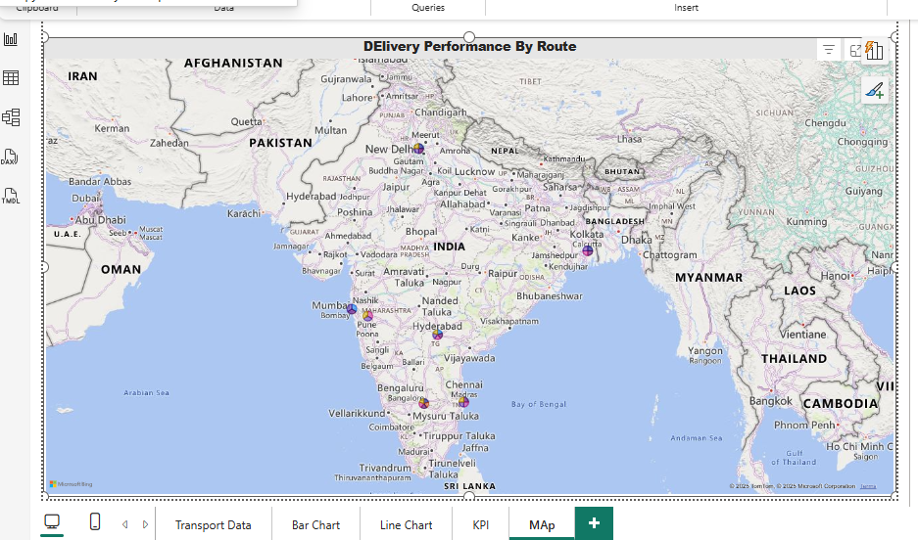
4.Dashboard Visualization:
